27.71: a)
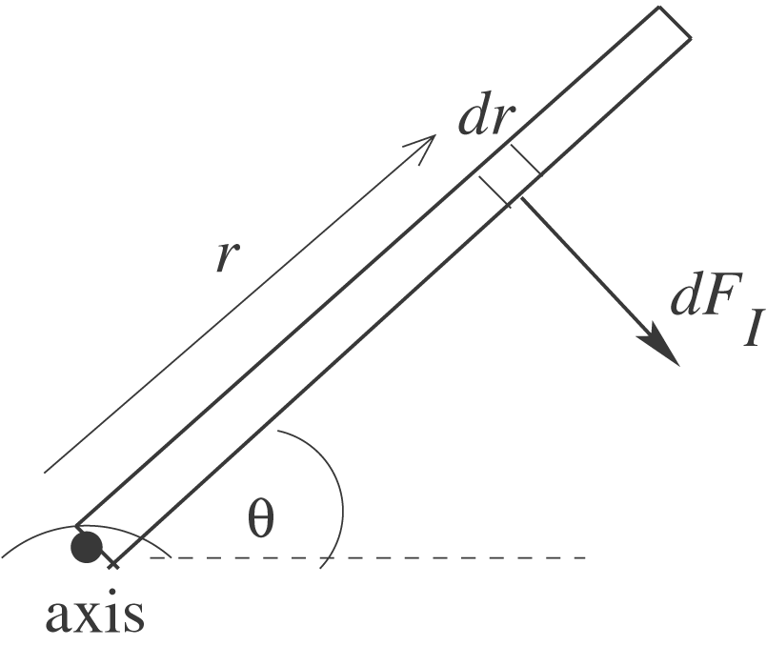 Divide the rod into infinitesimal sections of length dr.

The magnetic force on this section is 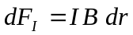 and is perpendicular to the rod. The torque 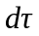 due to the force on this section is 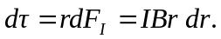 The total torque is 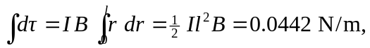clockwise. This is the same torque calculated from a force diagram in which the total magnetic force 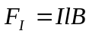 acts at the center of the rod.
b) 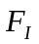 produces a clockwise torque so the spring force must produce a counterclockwise torque. The spring force must be to the left, the spring is stretched.
Find x, the amount the spring is stretched:
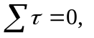 axis at hinge, counterclockwise torques positive
